**DAY -14 & 15 ESTIMATE (2-3 hours)**

**DESCRIPTION**

This assignment is based on web development using the Django framework of python. In this assignment you will be asked to create one project with one application followed by the proper structure of the application. Use Model, Views and Template to take the full advantage of Django. Make sure the final out of the application should display according to the following

constraint.

**CONSTRAINT: 01**

-- Give the name of the project as FIRSTPROJECT

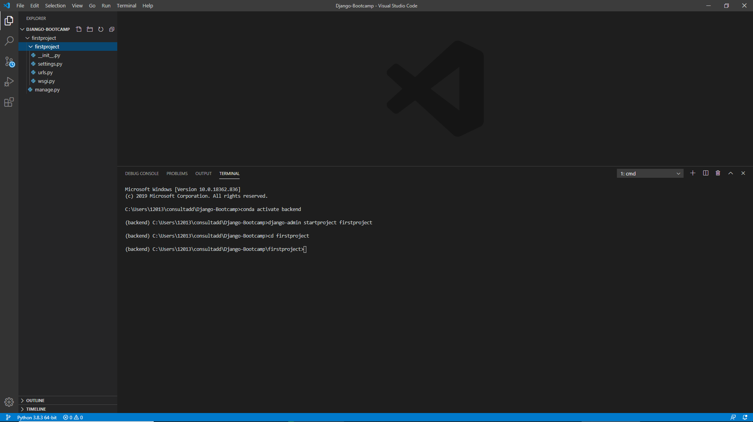

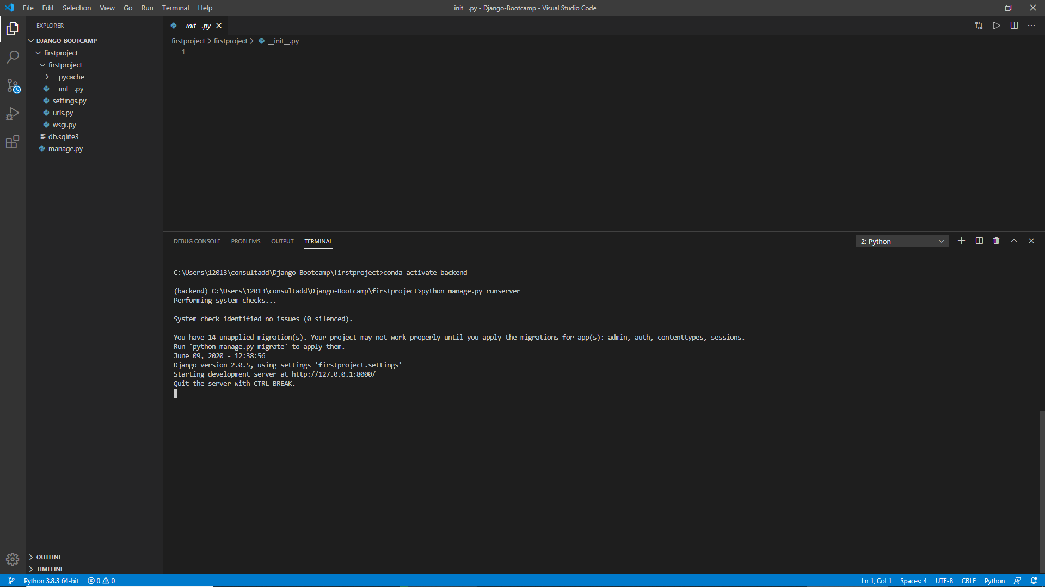

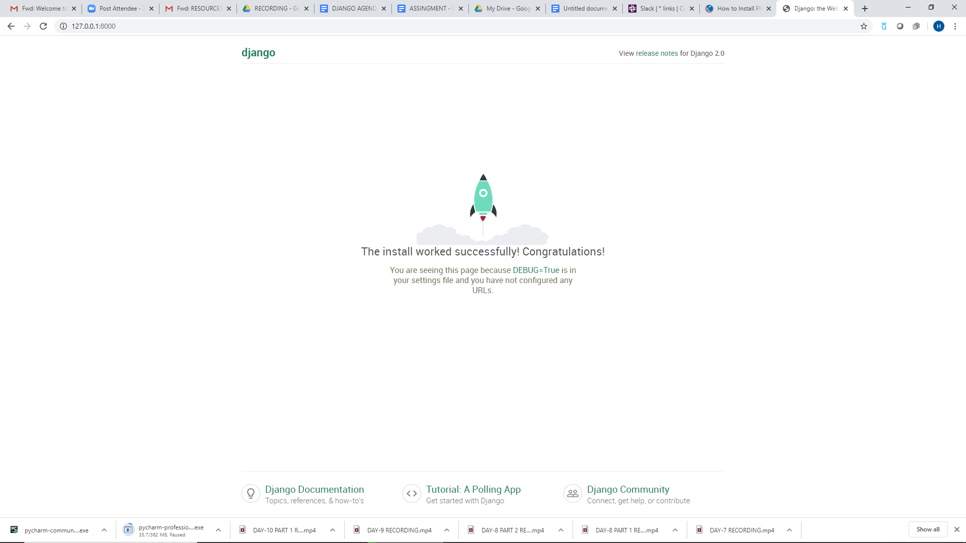

-- Give the name of the application as FIRSTAPPLICATION

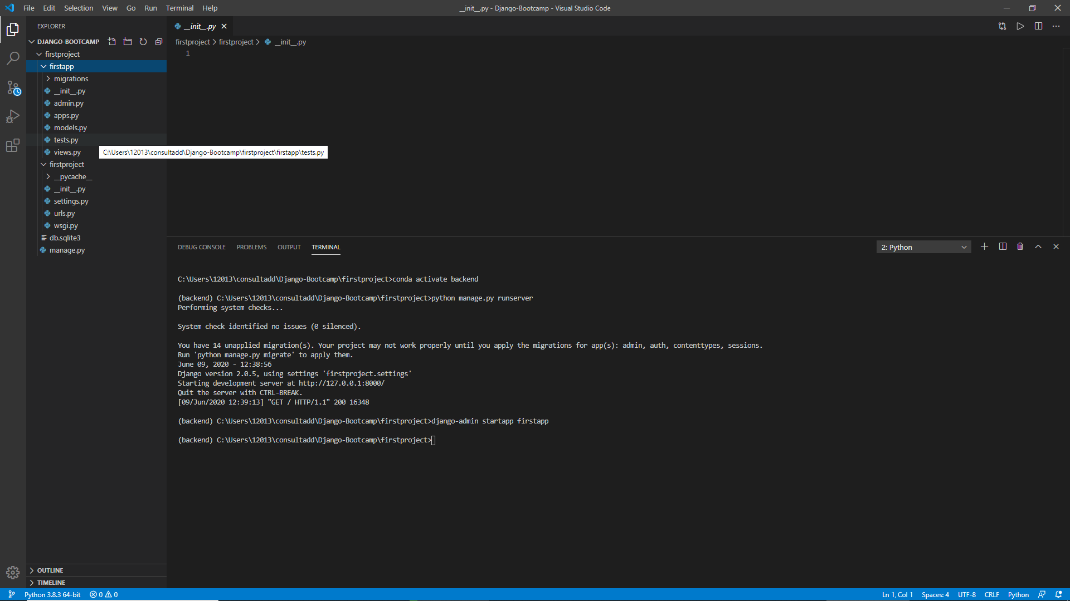

-- Allow views.py to be get properly mapped with urls.py file.

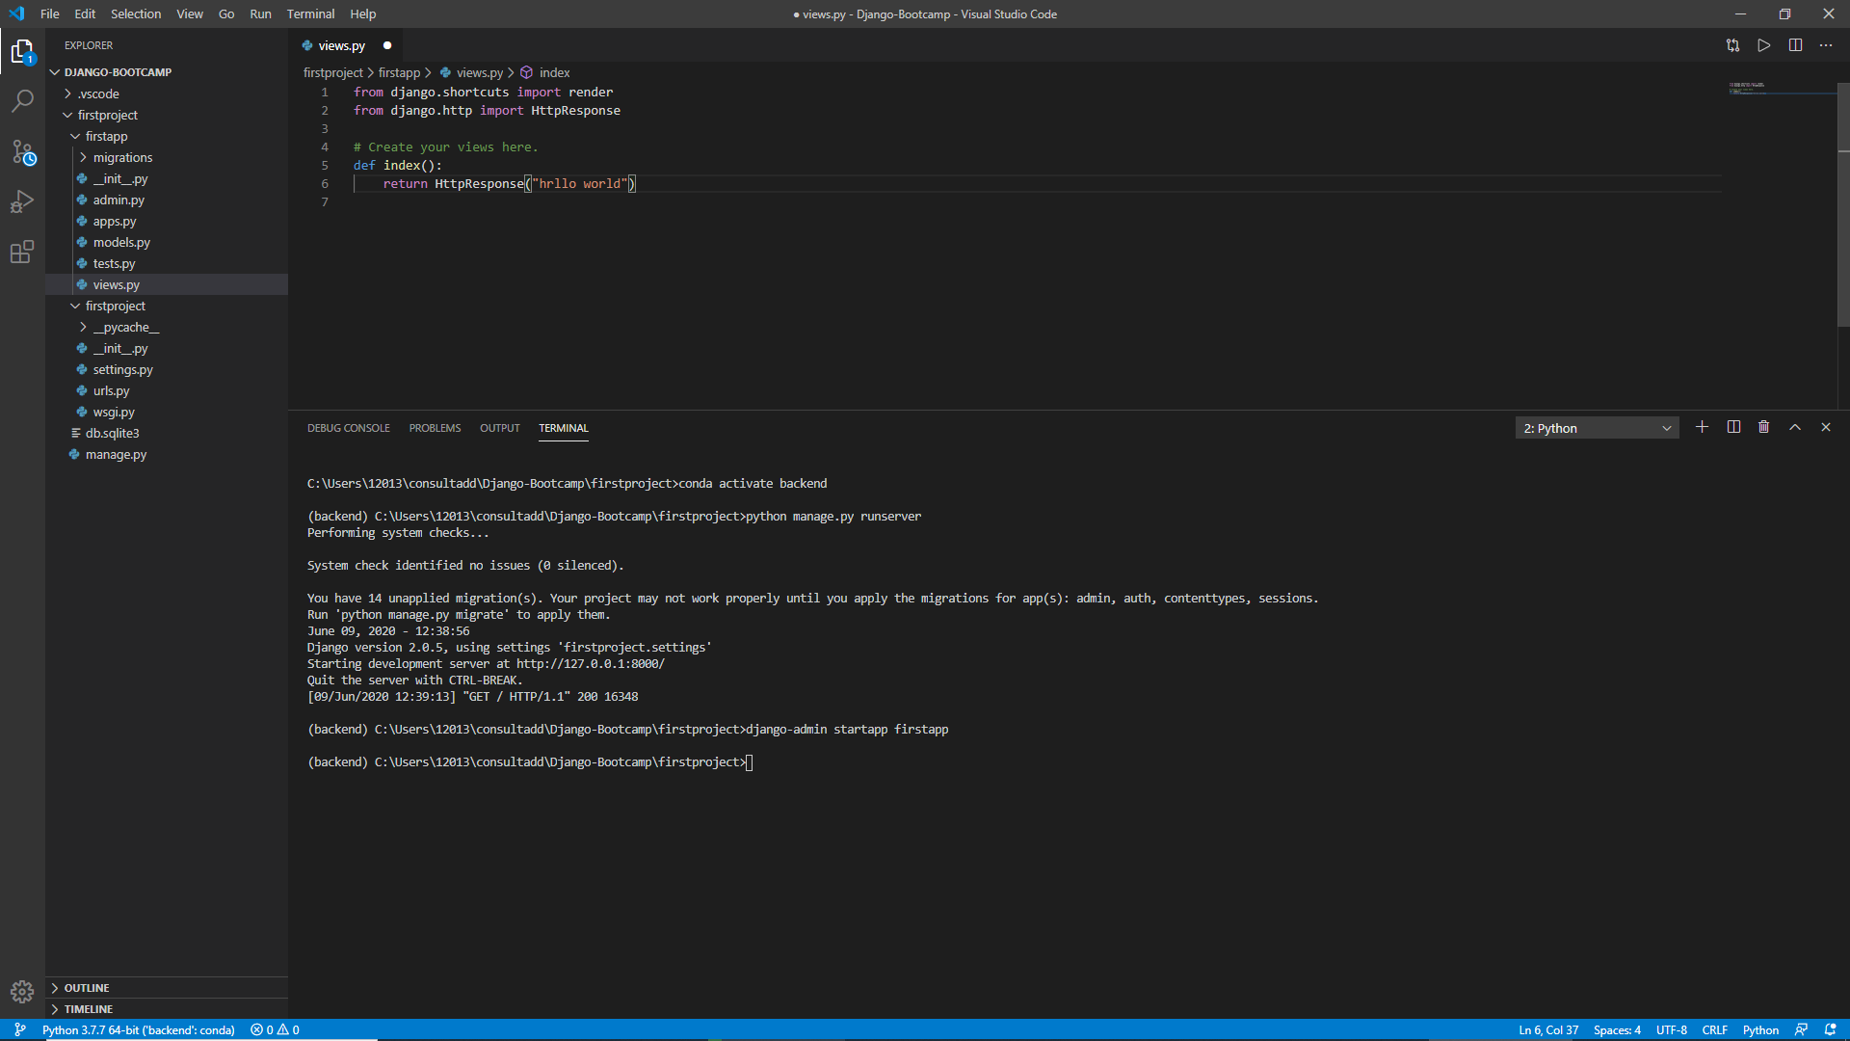

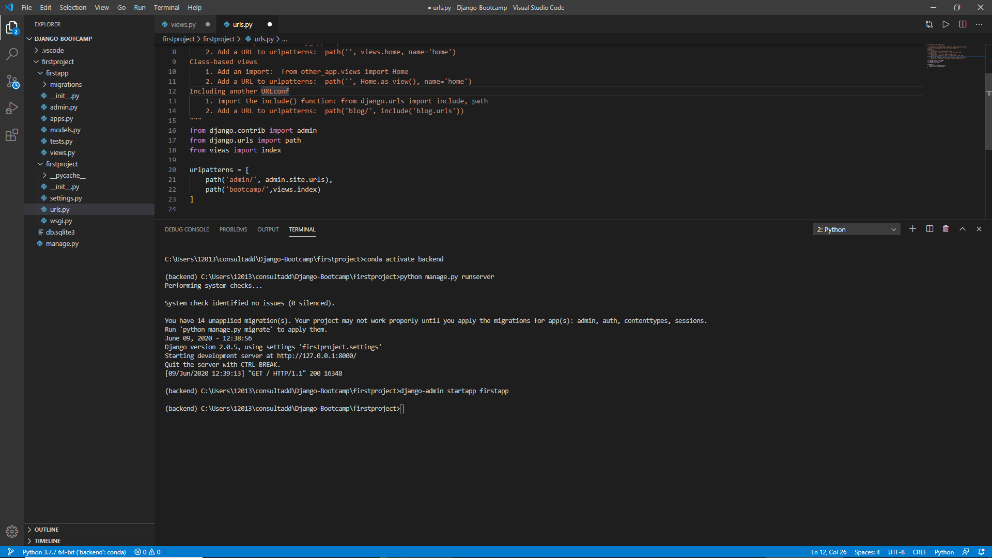

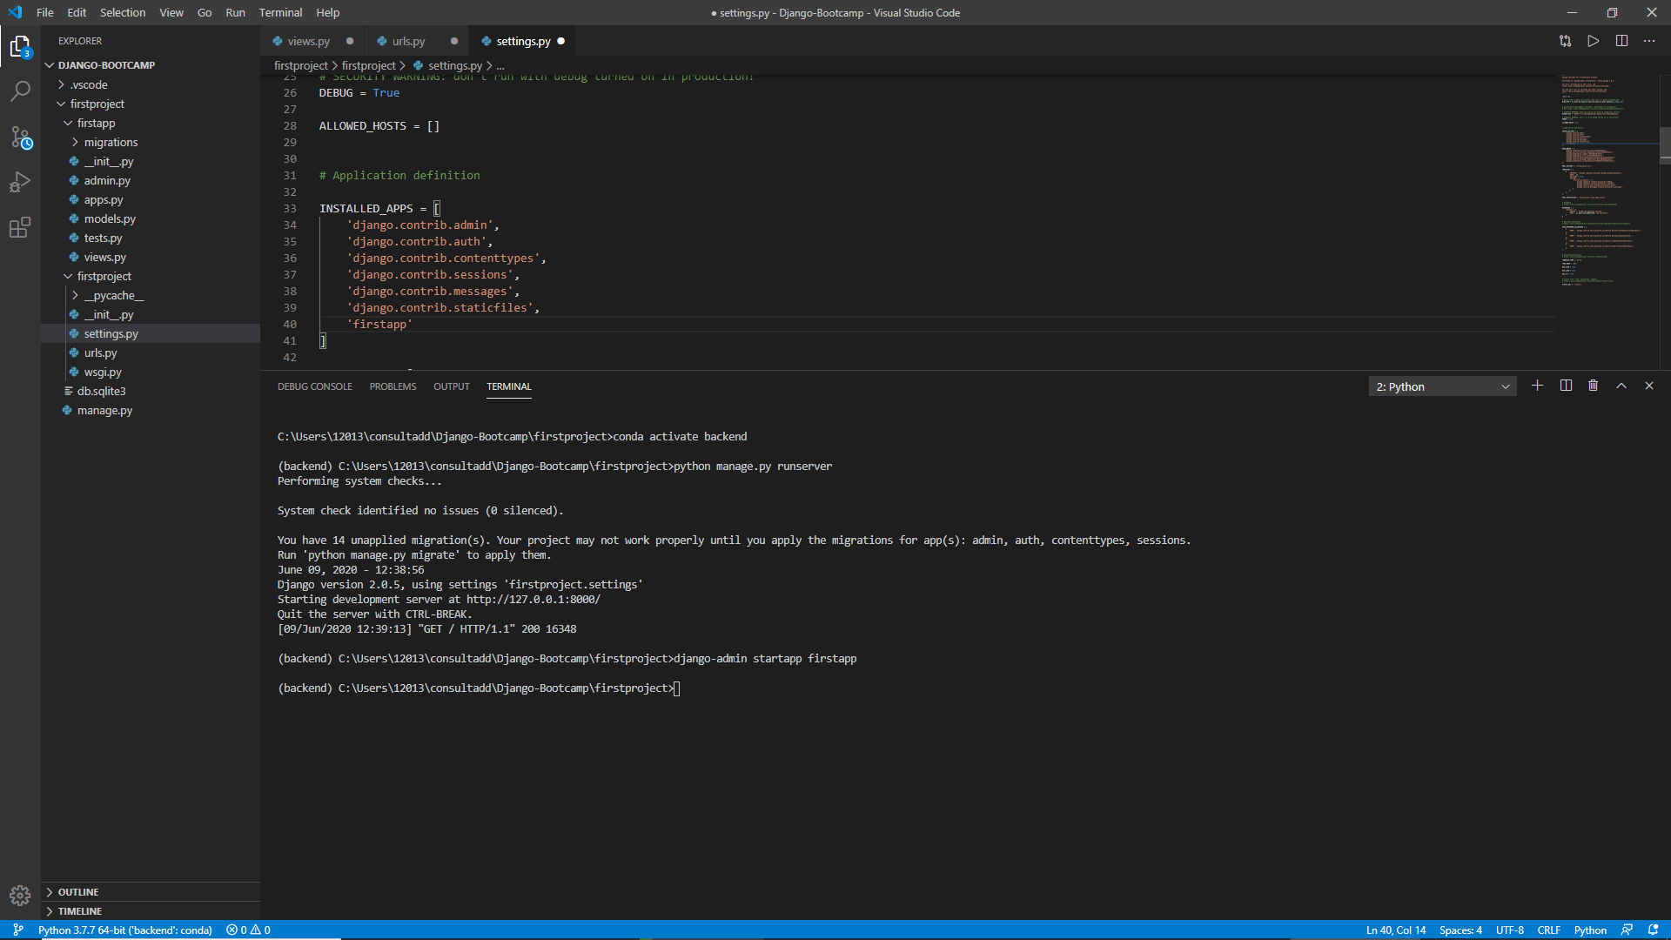

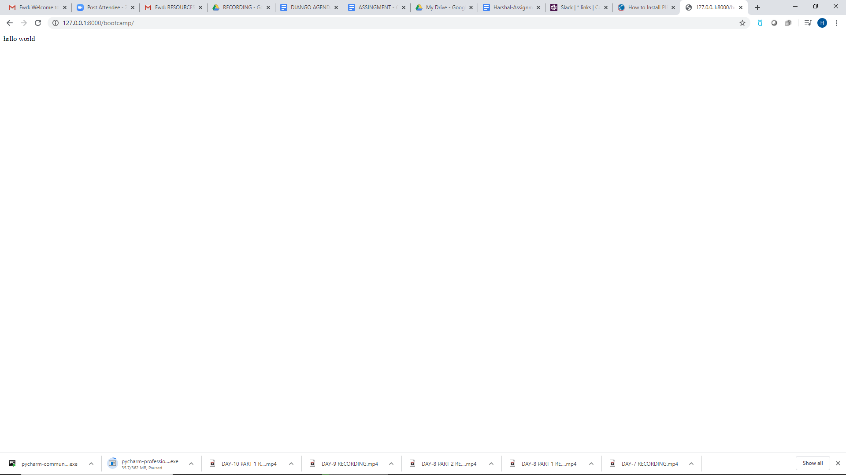

-- Use a template to create a generic HTML file that can display data like- Hi! Welcome to the innovation with Bootcamp training.

-- While working with the template make sure you give name "TEMPLATE_PATH" to actually connect to the os path.

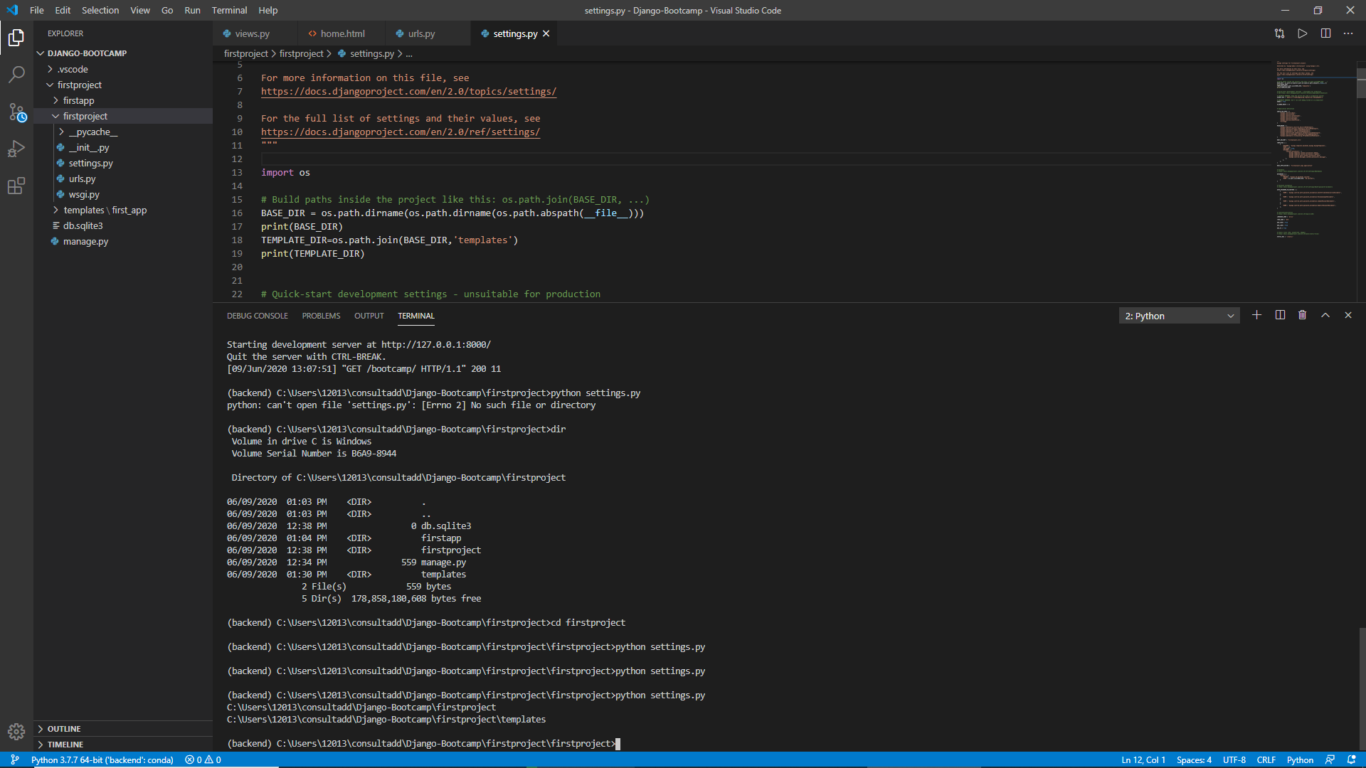

**CONSTRAINT: 02**

-- Make use of the Static files concept to display jpg file on the web page.

-- Make use of some other static files like CSS or JavaScript to change the font or color of the text.

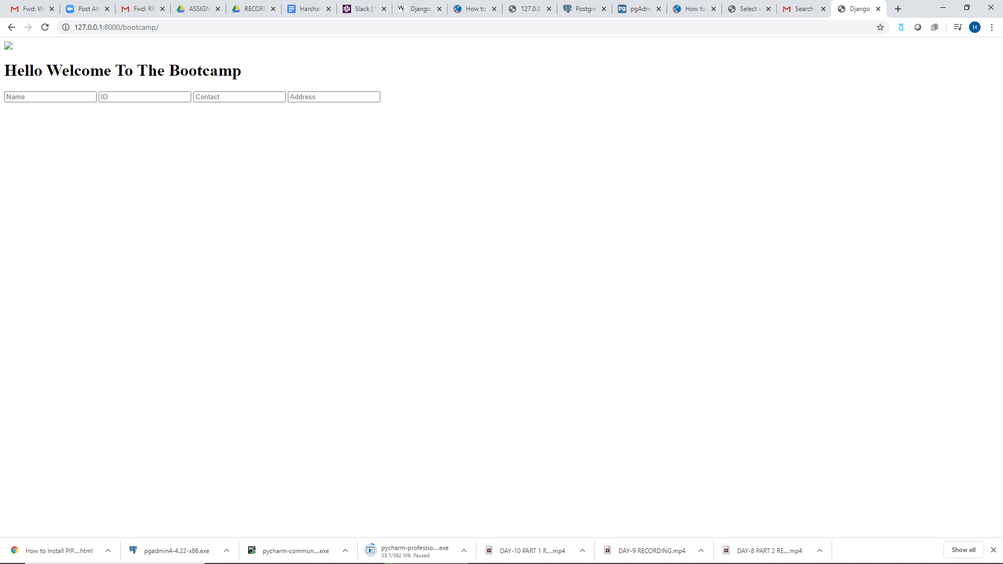

-- Create three models classes as - Name, ID, Contact, Address and migrate them into the database

